SIMPLIFYING SIMPLE MOVING AVERAGE COMPUTATIONS
By John Ehlers

A simple moving average of length N is computed by adding N values and dividing the sum by N. The process is repeated on a bar-by-bar basis. What could be easier? While conceptually easy, the coding for long moving averages can be tedious because there are so many terms. The tedium can be reduced by putting the summation in a loop. But looping is difficult to do in some applications, such as Excel. Another simplifying approach is to drop off the oldest value and add a new value to the moving average. But, this requires computing the initial value of the long moving average at least once. In this article I will show you two ways to compute the simple moving average with ease.

In Z Transform notation, a unit delay is represented by Z⁻¹. The Transfer response is the output of the filter divided by its input. Thus, the transfer response of an 8 bar simple moving average would be written as:

- H(z) = (1 + Z⁻¹ + Z⁻² + Z⁻³ + Z⁻⁴ + Z⁻⁵ + Z⁻⁶ + Z⁻⁷)/8

This same expression, written in EasyLanguage where a delay of N bars is represented in square brackets as [N], is written as equation 2.

- SMA = (Price + Price[1] + Price[2] + Price[3] + Price[3] + Price[4] + Price[5] + Price[6] + Price[7])/8;

Equation 1 is a simple finite series that can be written most generally in fractional form as, where Y(z) is the filter output and X(z) is the filter input:

3) 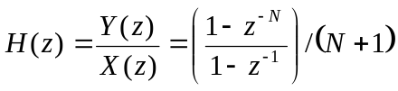

Equation 3 is identically equivalent to equation 1 if N=7, and is therefore a simple moving average. When we carry out the crossmultiplication of equation 3, we obtain:

Equation 4 provides the means to program an arbitrarily long SMA using just a few terms. The EasyLanguage equivalent of equation 4 is:

- SMA = (Price – Price[N] + SMA[1]) / (N+1);

Another SMA programming trick can be accomplished by recognizing that we don’t have to do the filtering all at one time. Rather, we can cascade filters. That means we can filter the output of a previous filter that takes the output of a previous filter, etc. Cascading filters is represented by multiplication in Z Transforms. Therefore, the SMA transfer response of cascaded filters can be written as:

For example, if K=3, we would have an 8 bar SMA. As a test, we can expand equation 6 to be:

- 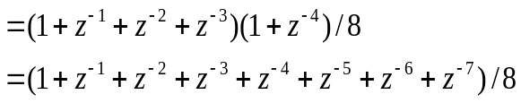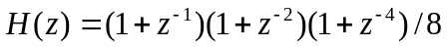

Thus, equation 7 shows that the cascaded filters expand to be identical with a SMA. In EasyLanguage, the cascaded filters would be written as:

- Value1 = Price + Price[1];
Value2 = Value1 + Value1[2];
Value3 = Value2 + Value2[4];
SMA = Value3 / 8;

I hope these little programming tricks will simplify the coding of your indicators and strategies.

John Ehlers is the President of MESA Software. He is a pioneer in introducing maximum entropy spectral analysis to technical traders through his MESA software. He has authored the book “Rocket Science for Traders”. Watch for his new book “Cybernetic Analysis for Stocks and Commodities” coming soon.

